Nature’s Harvest
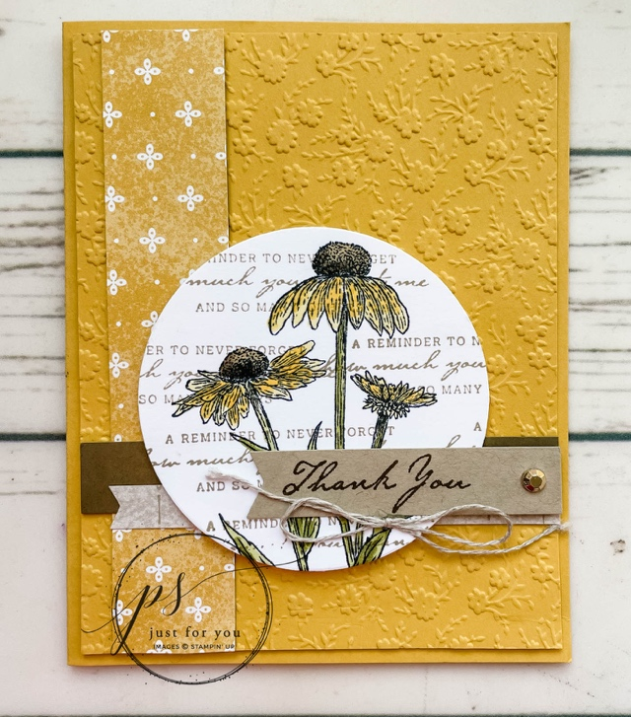
All images © 1990-2021 Stampin’ Up!®

Supplies:
- Stamp Sets – Nature’s Harvest (156495)
- Card Stock – Bumblebee (153077); Soft Suede (115318); Crumb Cake (120953); Basic White (159276); Harvest Meadow Designer Series Paper (156494)
- Stamp Pads – Crumb Cake (147116); Soft Suede (147115); Memento Tuxedo Black (1327058)
- Blends – Daffodil Delight Blends Combo (154883); Soft Suede Blends Combo (154906); Old Olive Blends Combo (154892)
- Misc. – Gilded Gems (152478); Linen Thread (104199); Ornate Floral 3D Folder (152725); Tailored Tag Punch (145667); Layering Circle Dies (151770); Stampin’ Dimensionals (104430); Mini Glue Dots (103683); Multipurpose Liquid Glue (110755); Stampin’ Cut & Emboss Machine (149653)

Measurements:
- Bumble Bee CS: 5-½” x 8-½” scored at 4-¼ and 4” x 5 ¼”
- Harvest Meadow Designer Series Paper: 1” x 5 ¼” and 3/8” x 4”
- Soft Suede: 5/8” x 4”
- Basic White: 3 ½” x 3 ½”
- Crumb Cake: ½” x 3”

Instructions:
- Dry emboss Bumblebee cardstock with the Ornate Floral 3D Folder using the Stampin’ Cut & Emboss Machine. Adhere to the card base using dimensionals.
- Adhere Harvest Meadow and Soft Suede CS strips to card base.
- Use Tailored Tag punch to banner the ends of the Crumb Cake CS and the remaining DSP. Adhere DSP banner to card base.
- Ink Coneflowers in Memento ink and stamp on Basic White CS. Use Daffodil, Old Olive and Soft Suede Blends to color image. Randomly stamp verse with Crumb Cake ink over colored image. Die Cut with Largest Laying Circle die and adhere to card base with dimensionals
- Use Soft Suede ink to stamp saying on Crumb Cake banner. Adhere to card base, embellishing with a Gilded Gem and a Linen Thread bow attached with a mini glue dot.

